MKU May 2019 Happenings

NEWSLETTER

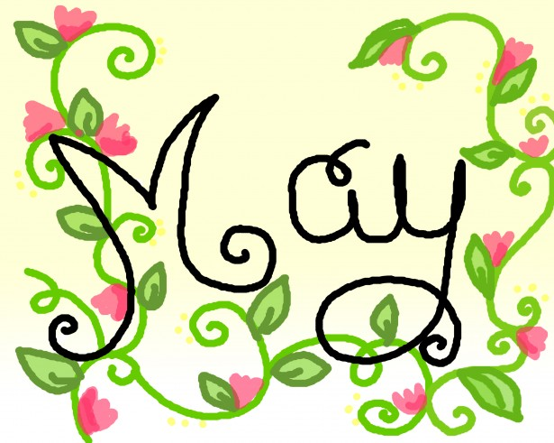
Celebrate May with us!

May is here, and with it, several great opportunities for our families and kids. This month will provide lots of wonderful activities including:

- Dental Presentation – Wednesday, May 8. Our primary kids will enjoy this second annual dental care presentation given by – get ready – The Tooth Fairy herself!
- Mother’s Day Breakfast – Friday, May 10,
8:15-9:30 am. Moms, please join us for our annual breakfast featuring a fresh omelet station and other goodies to honor some of the most important people in the world... You!
- Primary End of Year Awards Ceremony - Thursday, May 23. Primary students will be recognized for their accomplishments and parents are invited to join in the celebration. This is a great photo opportunity and a chance to visit with other parents. We’d love to see you all there!

Congratulations!

Our little ones are growing up before our eyes. Happy birthday to:

Mia C Madeleine E
Jude J Carter N
Karim S Zyheir L
Myra B Seyi O
Gabrielle L

Teacher of the Month

Ms. Amber Nguyen
Ms. Amber is never seen without a smile! She brings her happiness and positivity to the infant classroom, where she works with each baby on developmental skills. She has no shortage of love and affection for each child, talking to them, building their vocabulary, and letting them know they’re loved. Please join us in celebrating this excellent teacher!

Welcome to our new teachers:

Ms. Anmol – Floater
Ms. Jessica – Floater
Ms. Melissa – Asst. Teacher, Pre-Primary 1

Ask your kids about…

Our Reggio Emilia program for May is Dinosaurs! Art, music, sensory, and engineering projects provide hands-on discovery and the joy of learning.

- Mix up some dinosaur slime
- Play archeologist and dig for dinosaur bones
- Find out how your feet measure against dinosaur feet
- Cook up some gummy fossils
- Excavate dinosaur eggs
- Dance to the dinosaur stomp
- Construct your own dinosaur skeleton
- Play the dinosaur counting game
- Explore and make your own paleo art

…and much more!!!

Please write us a review and share your
positive experiences with
other parents!

REMINDERS

If your child will be leaving us at the end of the school year or throughout the summer, please let us know as soon as possible. We have a list of children hoping to enroll at MKU and would like to be able to give them dates of our next openings. Thank you!

